IAM- IDENTITY AND MANAGEMENT ACCESS
USERS

Objectives-
• To study AWS Identity and Access Management and understand its significance in managing secure access to AWS resources.
• To create an IAM user using the AWS Management Console as a best practice instead of relying on the root account.
• To set up console login credentials for the IAM user by defining a unique username and a strong custom password.
• To assign appropriate permissions to the IAM user through AWS managed policies.
• To provide access to Amazon S3 by attaching the AmazonS3FullAccess policy.
• To validate the IAM user setup by successfully signing in through the IAM user login page.
• To analyze permission restrictions and understand how AWS enforces access control based on assigned policies.

Step 1: Open the IAM Dashboard-
- Log in to the AWS Management Console using valid credentials.
- Navigate to AWS Identity and Access Management from the list of available services.
- Observe the IAM Dashboard, which displays security status and recommended best practices.
- In the left navigation pane, under Access Management, select the Users option.

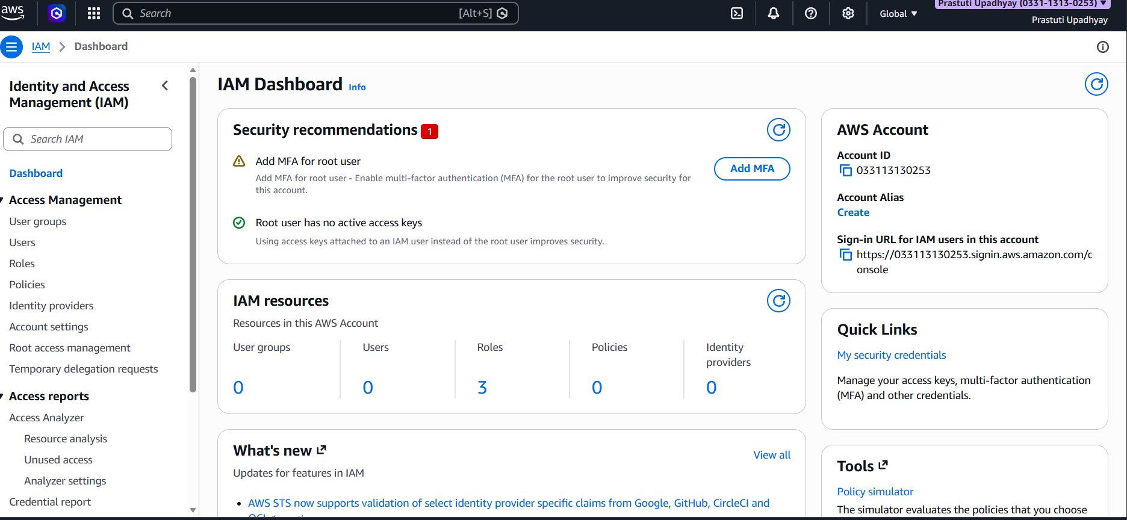.

Step 2: Viewing the Users List-
- Open the Users section in AWS Identity and Access Management.
- The Users page will be displayed, showing Users (0), which indicates that no IAM users have been created.
- An empty table is shown with the message “No resources to display.”
- Click the Create user button located at the top-right corner to begin creating a new IAM user.
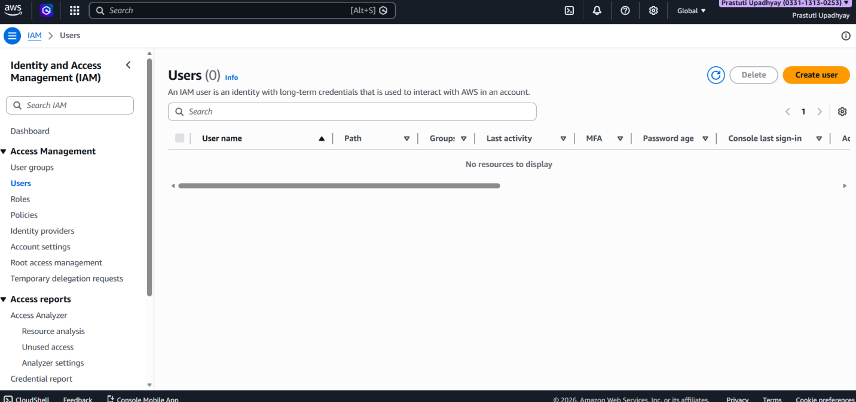

Step 3: Specifying User Details-
- The Create User wizard is displayed at the Specify user details stage in AWS Identity and Access Management.
- Enter a unique and appropriate User name for the IAM user.
- Enable the option “Provide user access to the AWS Management Console” to grant console login access.
- Choose Custom password and assign a strong, secure password for the user.
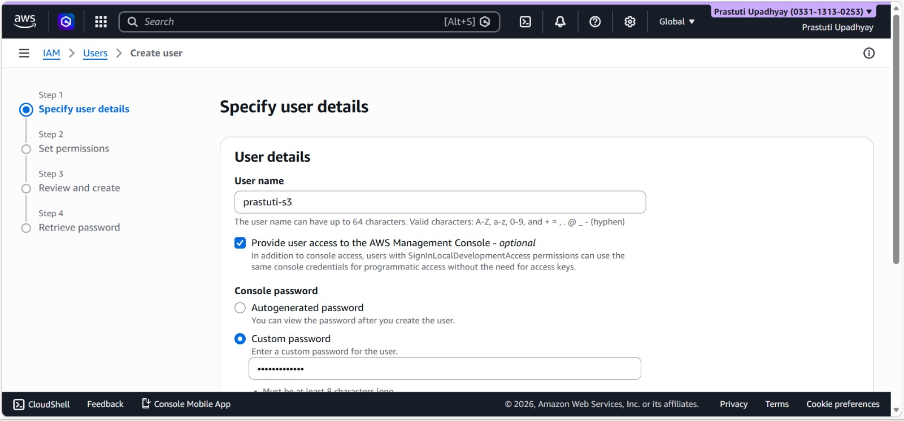
Step 4: Configuring Password Settings-
- Navigate to the password configuration section in AWS Identity and Access Management by scrolling down the page.
- Confirm that the Custom password option is selected.
- Ensure that the checkbox “Users must create a new password at next sign-in” remains unchecked.
- Click Next to continue to the subsequent step.
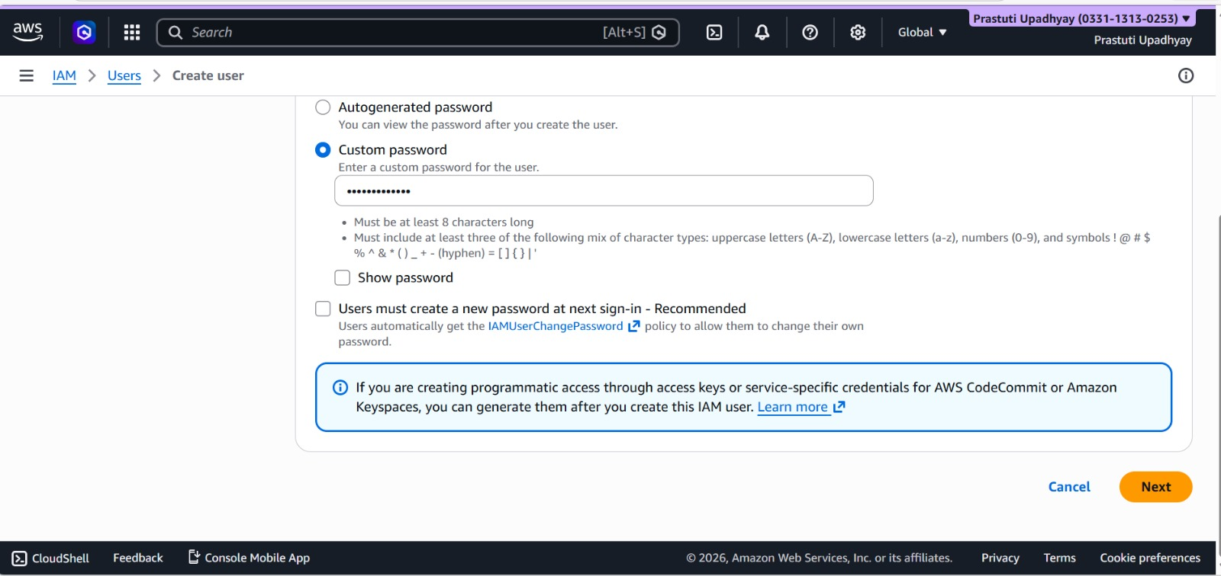

Step 5: Set Permissions for the User-
- The wizard proceeds to the Set permissions stage in AWS Identity and Access Management.
- Select the option Attach policies directly to assign permissions manually.
- In the search bar, enter S3 to filter relevant policies.
- From the displayed results, choose AmazonS3FullAccess to grant access to Amazon S3.

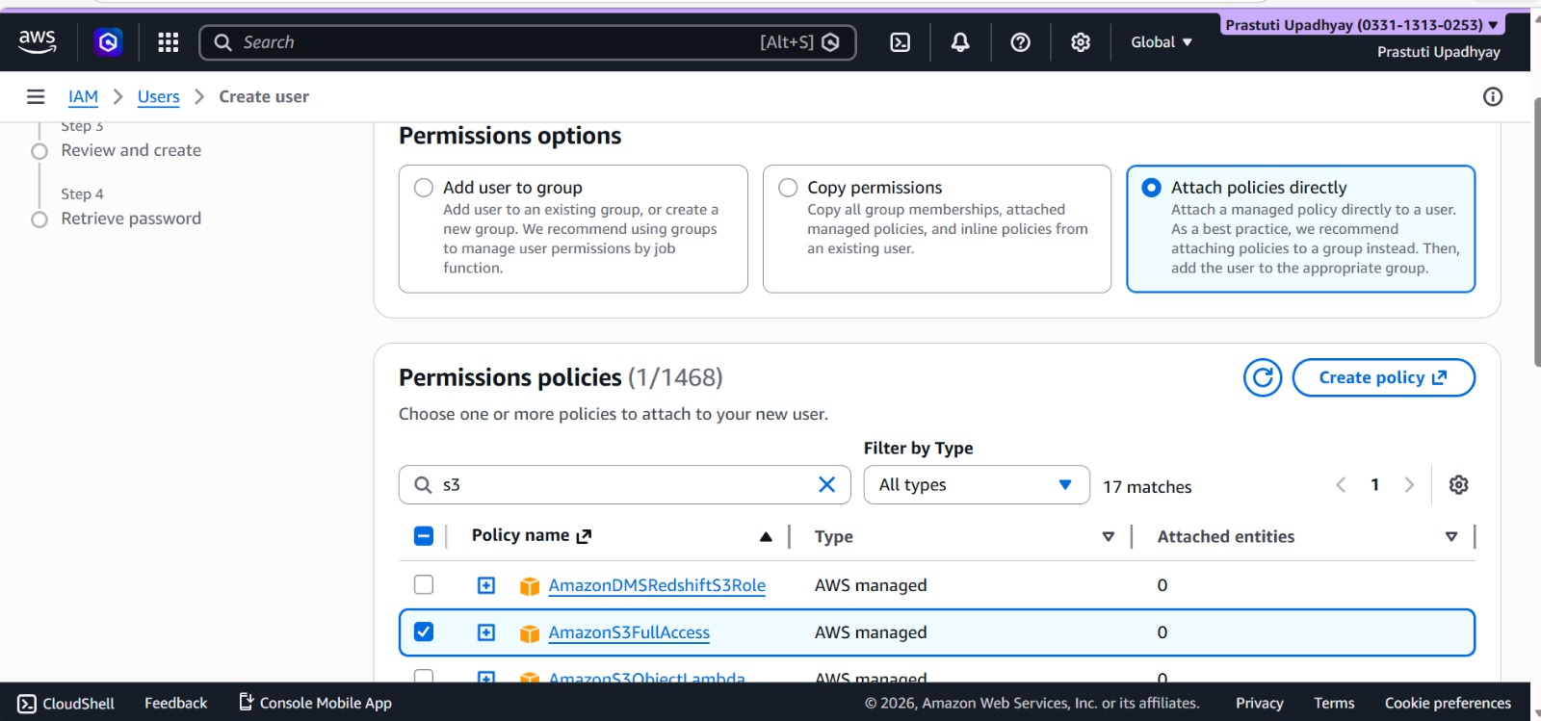

Step 6: Review User Configuration-
- The Review and Create page is displayed in AWS Identity and Access Management.
- Verify the following details:
  - Username – ensure it is correct.
  - Password type – confirm Custom password is selected.
  - Attached policy – check that AmazonS3FullAccess is listed.
- After confirming all details are correct, click Create user to complete the setup.
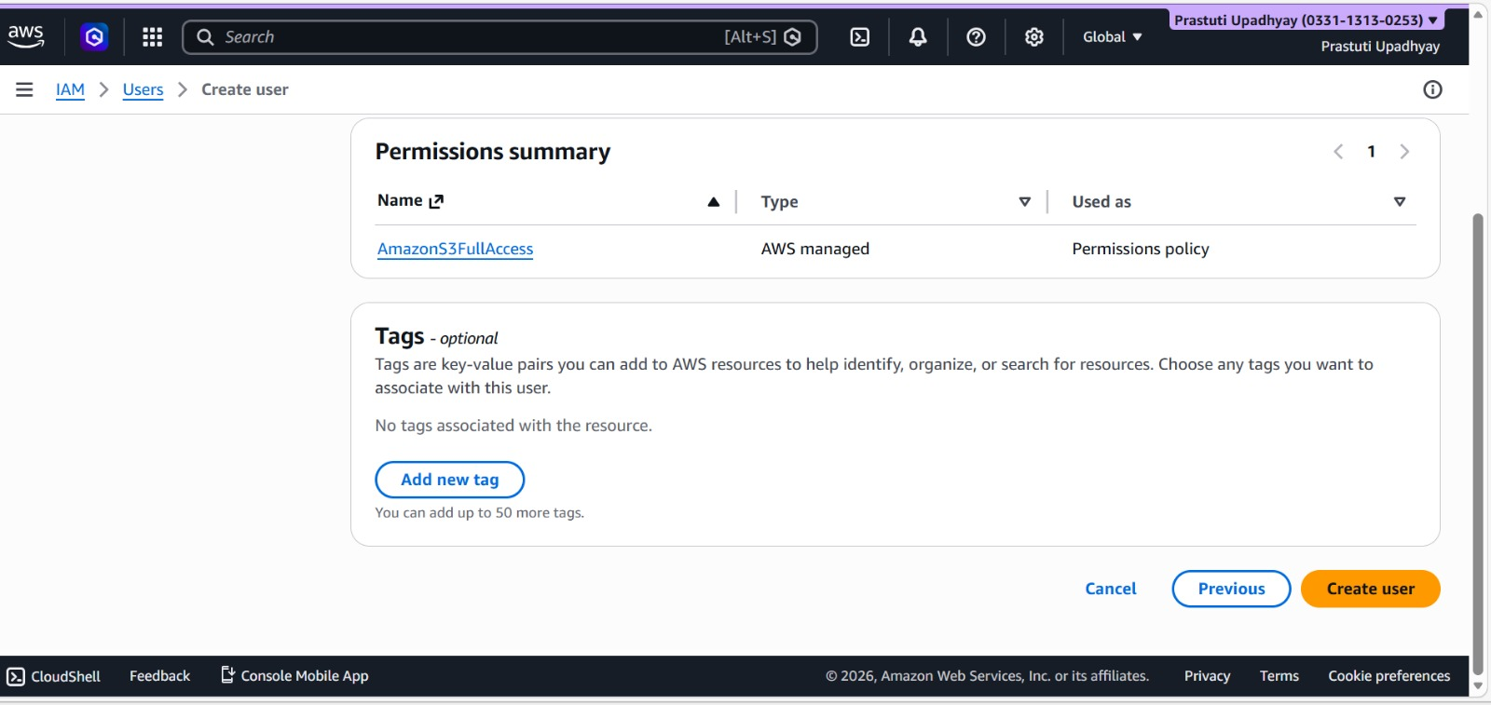

Step 7: Retrieve Login Credentials-
- The system displays the Retrieve password screen in AWS Identity and Access Management.
- Note the following login information provided:
  - Console sign-in URL – the URL used to access the AWS Management Console.
  - IAM username – the username assigned to the newly created IAM user.
  - Password – the custom password set during user creation.
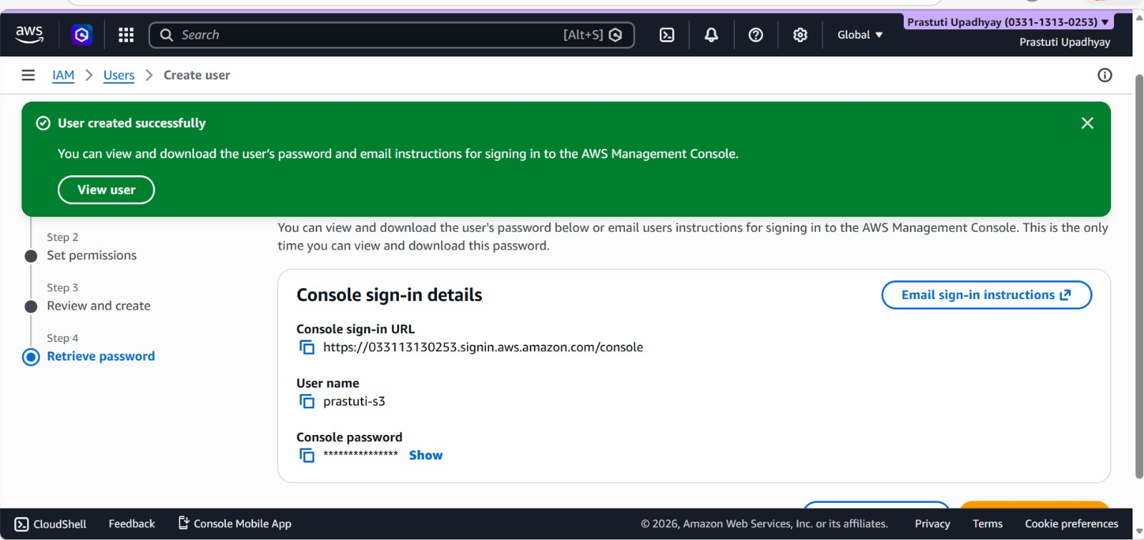

Step 8: Open the IAM User Sign-In Page-
- Open the IAM sign-in URL provided during user creation in a web browser.
- The AWS login page will appear.
- Enter the following credentials:
  - Account ID – the AWS account ID associated with the IAM user.
  - IAM username – the username assigned to the IAM user.
  - Password – the custom password set during creation.
- Click Sign in to access the AWS Management Console as the IAM user.

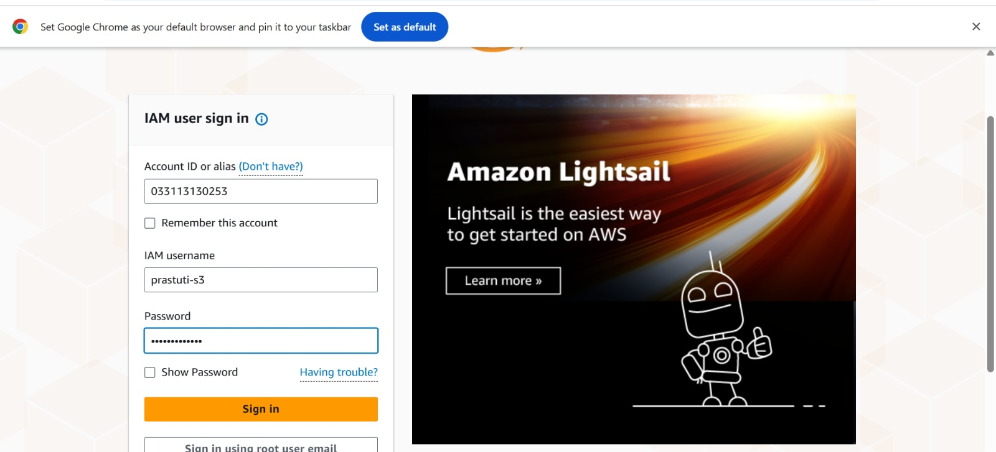

Step 9: Verify IAM User Login-
- After signing in, the AWS Management Console opens for the IAM user.
- The top-right corner displays the logged-in IAM username.
- Attempting to access services such as Billing or AWS Health may show Access Denied, since the user has only AmazonS3FullAccess permissions.
- This confirms that the IAM user’s access is restricted to Amazon S3 as intended.
